Design Documentations

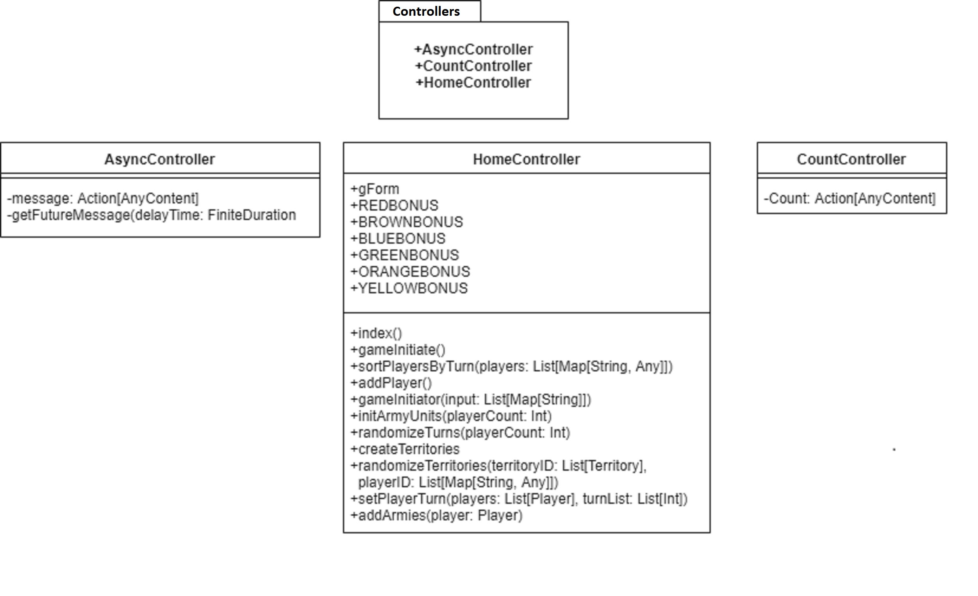

These are UML diagrams of the Controllers package and the classes contained in it. These classes create actions that handle requests and deal with other things.

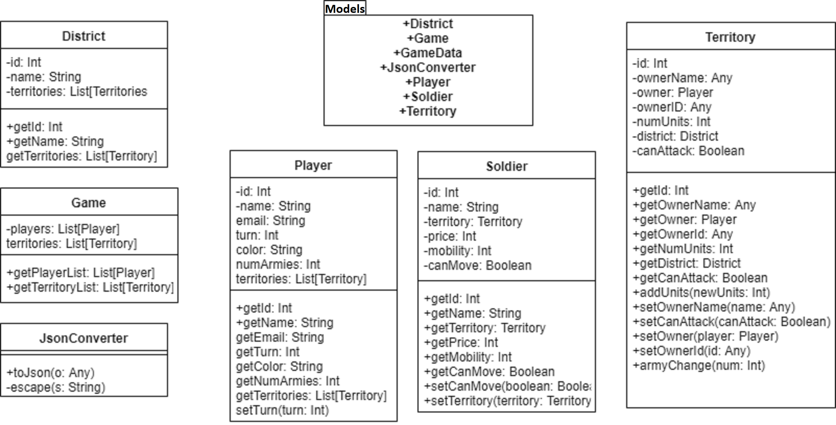

These are the UML diagrams of the Models package and the classes contained in it. These classes have the models and code of the objects that are using in the program.

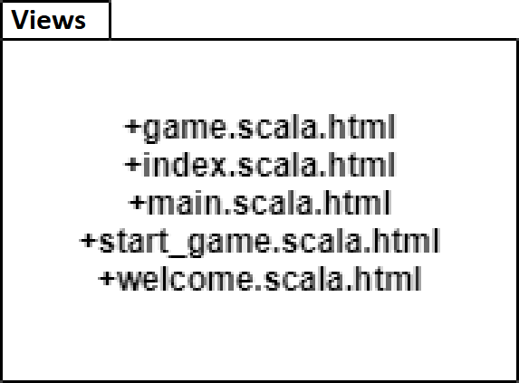

This is the UML diagram of the Views package. This package contains all the HTML code that is used in this project to have the webpage and features the way they are.